

Cocos System

AMST816: Application Design Specification

Version: 0.1
Date: 30 Nov 2016

Document Sign-Off

Revision History
Revision Date | Version | Updated by | Summary of Changes
2016-11-30 | 0.1 | Liu De Xing | Initial version

Sign-off List
Name | Department & Role | Signature | Date

Sign-off Notes
Name | Note

Table of Contents

1. Introduction 1
1.1. Purpose 1
1.2. Scope 1
1.3. References 1
1.4. Definitions and acronyms 1
2. System Components Index 1
3. Interface Specification 2
4. Reference Code Specification 2
4.1. Reference Code Summary 2
4.2. Reference Code Details 2
4.2.1. New reference codes 2
5. Data / Object Design 2
5.1. Physical Data Design 2
5.2. Technical Object Design 2
6. Processing Specifications 3
7. Program Modules List 3
8. Design Dependencies 3
9. Operational Special Handling 3
9.1. Messages and Actions for Operation Monitoring 3
9.2. Fallback and DRP Procedures 3
9.3. Restore and Rerovery Procedure 3
10. Hardware & System Software List 3
11. Security & Control Specifications 3

Introduction

Purpose
This document specifies the technical and security design details of a purchasing system.

Scope
This document includes below portions:
- System Technical Architectural.
- System Component and Processing.
- System Security Architectural.

References
Requirement:
- Employer can login to the system and raise a purchase request.
- Manager can approve the purchase request.
- Supplier can login to the system to enquire the purchase request.

Definitions and acronyms
Cocos | The name of this purchasing system.
Node.js | A JavaScript framework for developing Brower/Server applications
B/S | Browser/Server
SQL | A language to create/update/insert/delete data in the structure database system.
Cookie | A data which stored in client for keeping the Http session
Session | Http/Https session
TLS | Transport Layer Security
HTTP | HyperText Transfer Protocol
HTTPS | Hyper Text Transfer Protocol over Secure Socket Layer.
PKI | Public Key Infrastructure
CA | Certificate Authority

System Components Index
The system contain below components:
- Web server – Nginx
- Backend components written in Node.js
- Front-end components written in Javascript+HTML+CSS
- Data store in MYSQL.

Interface Specification
N/A.

Reference Code Specification

Reference Code Summary
Reference Code | Reference Code description
Nil

Reference Code Details

New reference codes

Reference Code | Reference Code description | Reference Code Value Fmt | Reference Code Abbrev Fmt  (if applicable)
Nil

Reference Code Value | Reference Code Abbrev  (if applicable) | Reference Code Description | Remarks
nil

Data / Object Design

Physical Data Design

The system will contains several tables to store the information:
- Account table to store the user and user login information. E.g. id, password, etc
- Parameter tables to store the parameter.
  - User group list
  - Country list
  - Company list
  - Function list
  - Product list
  - Product categories
  - Group – function Access matric
- The purchase table to store all purchase details.
- The contract table to store the purchase contract.
- The history table to store the purchase history.
- The logging table to store the logging of user activities (i.e. login, logout, create, update, etc.) for audit purpose.
- The inventory table to store the current available product information (e.g. quantity, purchase date, etc).
- The finance table to store the finance information for the purchase contract.

Technical Object Design

The system will use node.js express framework to build the B/S system. Separate modules will be built for different purpose:
- User module for user management and authentication
- Purchase module for purchase activities.
- Contract module for actives related to contract.
- Finance module for accounting related activities.
- Inventory module for inventory management.

For every user group, separate sub-module will be built to implement different type of user activity. For example, for purchase, buyer sub-module will implement the create, update, submit, publish, complete, cancel activity for buyer, and manager sub-module will implement approve activity for manger.

Processing Specifications

System Architecture
The system is a Browser/Server mode system using the MVC model. The user interface will be built in HTML+Javascript+CSS as a webpage. User perform the request thru the browser in a PC, the request will be pass to back-end server thru HTTPS. The back-end web-server will dispatch the request to the system back-end, which is written in node.js. All data are stored in MYSQL database in the server. The system back-end access the MYSQL database thru local socket.
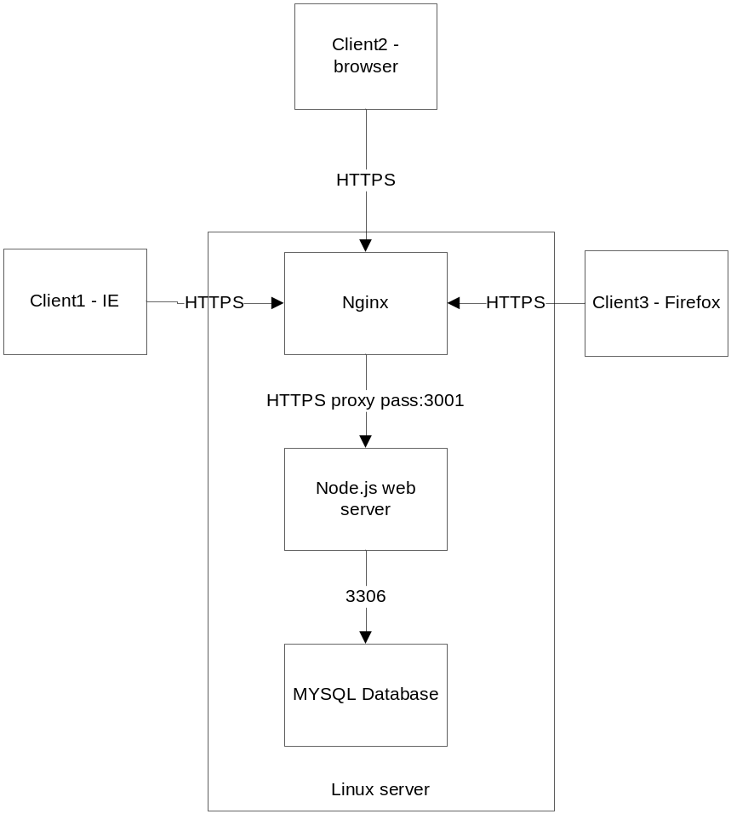

Purchase Processing

Authentication
User must login using the email address and password. User can register a new account with minimize authority (thru user group setting). The ID administration will validate the user’s information by perform background screening, and update user group to grant suitable access right. Different user group can only perform a set of predefined user functions. All other request will be rejected.

Purchase
There are mainly three roles in the purchase purpose. The buyer, and buyer’s manager and the supplier/vendor.
The buyer can create a purchase request, update it and submit it for approval.
The manager can approve the purchase request which is submitted.
After the purchase request is approved, the supplier can check the detail purchase request, and provide the acceptable price to the buyer.
The purchase request can only valid to be marked confirmed after the supplier accept the price and a contract already been signed.
Upon receiving the product, the buyer can mark the purchase as complete and close it.
The whole life cycle of a purchase is:

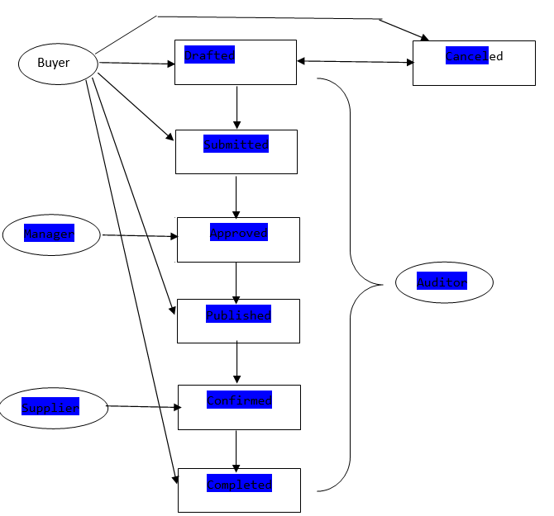

System administration
The administration function is mainly for system maintained in case the data cannot be corrected thru the normal user function.

Program Modules List

NA.

Design Dependencies
NA

Operational Special Handling

Messages and Actions for Operation Monitoring
NA

Fallback and DRP Procedures
NA

Restore and Rerovery Procedure
NA

Hardware & System Software List
S/N | Hardware | Type | OS | Software List
1 | Web Server | Hardware | Linux
2 | Database | Software | Linux | MYSQL
3 | Development Language | software | Linux | Node.js
4 | Client | Hardware | Windows | Browser. IE, Firefox, Chrome

Security & Control Specifications
For data transfer security, the HTTPS will be forced enabled in data transfer between client and server.
For data protection, only authorized user can only view the data which is related to him.
For privacy protection, the sensitive data should be encrypt before store into the database.

The security architecture:



End of document–AMST816: Application Design Specification

